Email Blast from Carrier to Agent

[Agent Name]

Subject line: 14.6 million properties across the US are at risk of flooding¹
__________________________________________________________________________

Main header:

Help your policyholders protect their homes from flooding
— easily and affordably

Many homeowners mistakenly think that because they do not live in a high-risk flood area, they are not exposed to flooding or they are covered by their homeowners policy for flood-related losses. According to the National Flood Insurance Program, 40% of flood claims occur outside of high-risk flood zones, yet only 1% of homeowners living in these areas purchase flood insurance. You can help close the protection gap by educating policyholders about their flood risk and offering them an affordable solution they will appreciate — the Inland Flood Coverage Endorsement. Start by sharing the facts:

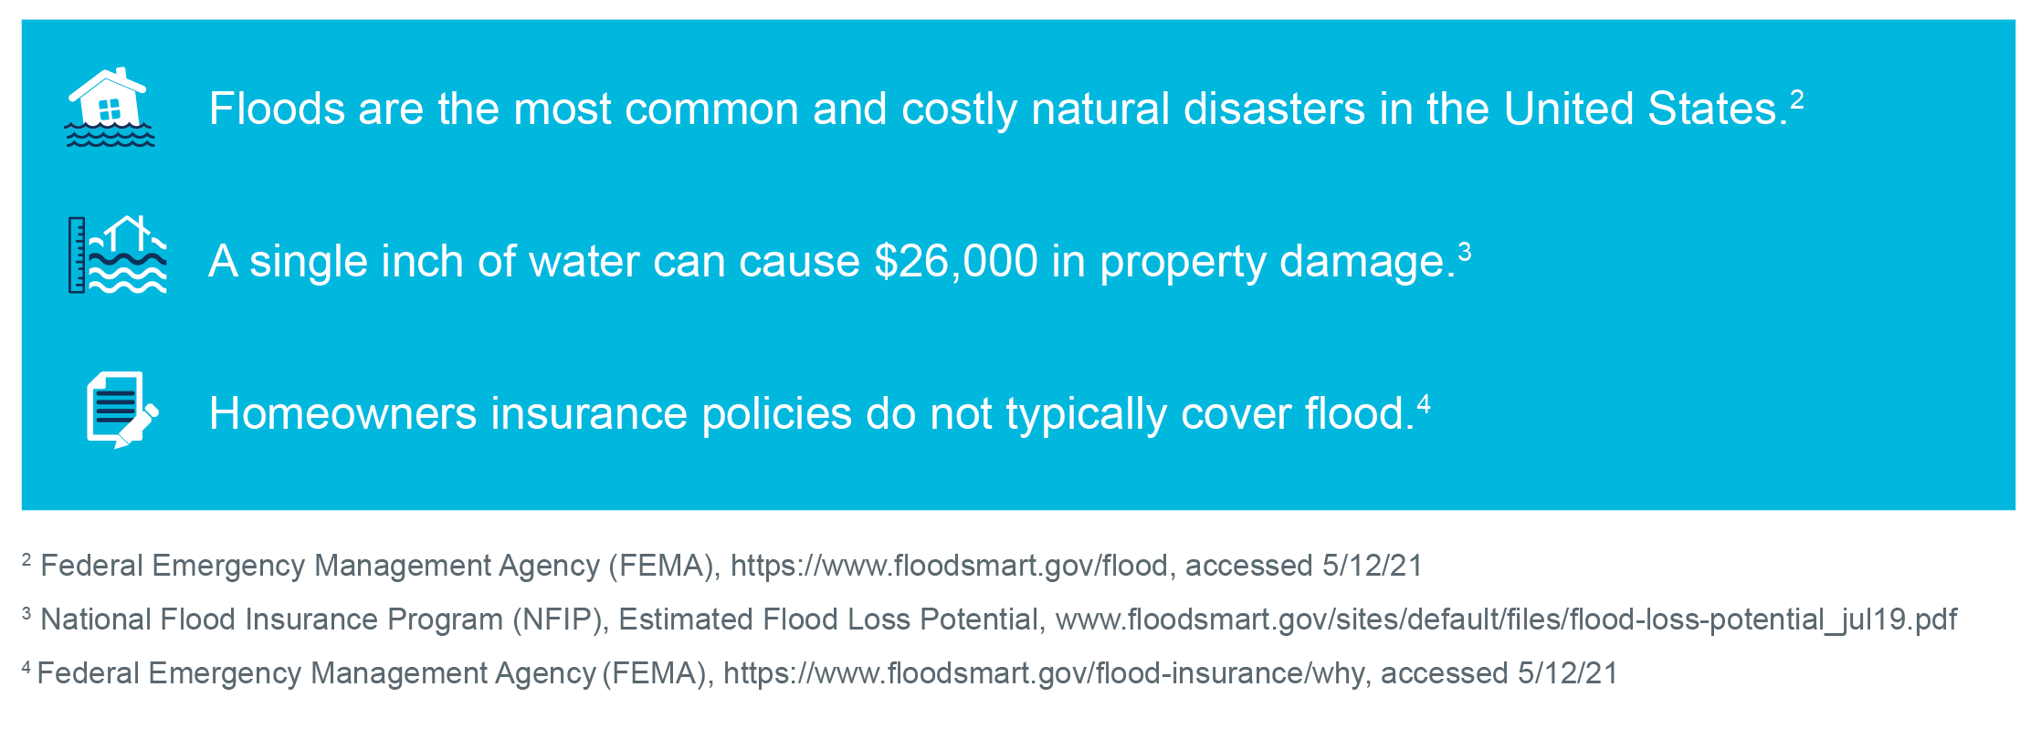

The Inland Flood Coverage Endorsement is designed for policyholders living in low-to-moderate risk areas that previously may not have purchased flood insurance. It covers the dwelling, other structures (like a shed or detached garage) and personal property, including personal property in a basement. It also provides coverage for debris removal and additional living expenses.

The Inland Flood Coverage Endorsement makes it easy to add flood coverage to a homeowners policy. Coverage from [$000] up to [$000] is available, and premiums start as low as [$000]. Let’s work together to close the protection gap.

Find out more by visiting our agent portal [website URL].

Sincerely,

[Carrier Name]
[Phone]
[Email]
[Website]

[Carrier/Company Logo]

Note: This coverage does not satisfy federally regulated mortgage lender requirements for flood insurance.

¹The First National Flood Risk Assessment, FirstStreet.org, 6/29/20.

© 2021 Munich Reinsurance America, Inc. All rights reserved. This material is for information purposes only. Any descriptions of coverage contained in this material are meant to be general in nature and do not include nor are intended to include all of the actual terms, benefits, and limitations found in an insurance policy. The insurance policy and not this document will form the contract between the insured and insurance company, and governs in all cases. This insurance product is not affiliated with the National Flood Insurance Program.

