Subject line: Is your home protected against flood? We can help.

Dear [Customer Name],

The risk of flooding is on the rise for all of us; however, most traditional insurance policies do not cover flood damage to your home or belongings. In recent years, rainstorms and snowstorms have become more intense and frequent, leading to flooding in areas that did not flood in the past. That’s why it’s important to protect the life you’ve built with our Inland Flood Coverage Endorsement, even if you live in an area with low-to-moderate flood risk.

Here are some key facts to consider:

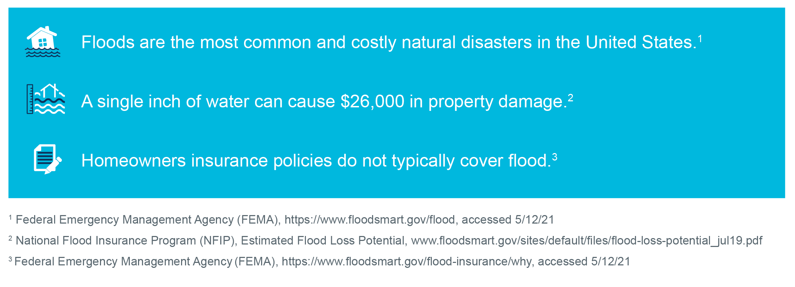

While these facts are concerning, there is a very simple and affordable solution. Our Inland Flood Coverage Endorsement is designed for homes in low-to-moderate risk areas and protects your home and contents. This inexpensive coverage attaches to your homeowners policy and provides you with peace of mind, knowing you have protected your home from flood damage.

Contact me to add the Inland Flood Coverage Endorsement to your policy today and rest easy for nights to come.

I look forward to speaking with you soon.

[Agent's Name]
[Phone]
[Email]
[Website]

[Agent's Company Logo ]

© 2021 Munich Reinsurance America, Inc. All rights reserved. This material is for information purposes only. Any descriptions of coverage contained in this material are meant to be general in nature and do not include nor are intended to include all of the actual terms, benefits, and limitations found in an insurance policy. The insurance policy and not this document will form the contract between the insured and insurance company, and governs in all cases. This insurance product is not affiliated with the National Flood Insurance Program.

